# **Packaging, deploying, and running a Node application using Docker**

## **Objective:**

In this exercise, you will learn how to create a docker for a Node.js application.   
  
Docker is a powerful tool that enables developers to package their applications and dependencies into a container, making it easier to deploy, manage, and scale their applications.   
Although the following is a simple example, the same procedure can be applied to a more complex project.

## **Prerequisites**

Before starting the exercise, you should install Node and Docker Desktop on your local PC.

## **Steps by step instructions**

* Create a Node.js application: that prints "Hello World" in browser
* You will then create a Node app which serves some content.
* You will also create a file called **package.json** (using the **npm init** command) which defines all the project dependencies and sets other settings.   
  You will also experiment with installing a common module called “express”..

For this exercise, we will create a new directory called **docker_app** and create a file called **server.js** inside it which has a few lines of JavaScript for running a Node application.

**mkdir docker_app**

**cd docker_app**

**npm init -y**

**code .**

* Create a file called **server.js** and then copy the following code inside:

**'use strict';**

**const express = require('express');**

**const PORT = 9000;**

**const HOST = '0.0.0.0';**

**const app = express();**

**app.get('/', (req, res) => {**

**res.send('<h1>Hello World!</h1>');**

**});**

**app.listen(PORT, HOST, () => {**

**console.log(`Running on http://${HOST}:${PORT}`);**

**});**

* Change the contents of the **package.json** file to set the dependencies and other attributes.

**{**

**"name": "qa_node_app",**

**"version": "1.0.0",**

**"description": "A Node app using Docker",**

**"author": "mike <mike@qa.com>",**

**"main": "server.js",**

**"scripts": {**

**"start": "node server.js"**

**},**

**"dependencies": {**

**"express": "^4.16.1"**

**}**

**}**

* Change the author’s name and email
* Install all the dependencies by typing the following command in the Terminal window  
  **npm install**
* Start running your node app to see if it works by typing: **npm start**
* Open a browser and type:[**http://localhost:9000**](http://localhost:9000)

* You can now stop the app running by pressing Ctrl-C in the Terminal window.

# **Create a Docker container for your app**

### **Create a Dockerfile:**

In this part, you will create a Dockerfile that will be used to build a Docker image for your Node.js application.

* Create a file called **Dockerfile** in the same folder as **server.js**
* Include the following instructions for basing the image on node version 16 and installing the files on the Docker.

**FROM node:16**

**# Create app directory**

**WORKDIR /usr/src/app**

**# Install app dependencies**

**# An * is used to copy package.json AND package-lock.json**

**COPY package*.json ./**

**RUN npm install**

**# Bundle app source**

**COPY . .**

**EXPOSE 9000**

**CMD [ "node", "server.js" ]**

* Create a **.dockerignore** (dot dockerignore) file in the same directory as your Dockerfile with the following content:

**node_modules**

**npm-debug.log**

We will not copy the module files into the image because they can be created by the line **RUN npm install** in the Dockerfile.

### **Build the Docker image**

* Open a terminal window, navigate to the root directory of your Node.js application
* Run the following command to build the Docker image with the tag of say   
  **mike/qa-node-app**   
  **docker build . -t mike/qa-node-app**

Please note the dot ‘**.**’ In the middle of the command.  
You can change the tag but please make sure each letter of the tag is in lowercase  
  
This command will use the Dockerfile to build a Docker image of your Node.js application and tag it with the name that you specify.

### **Run the Docker container:**

* After the Docker image has been built, you can run a Docker container using the following command: **docker run -p 5000:9000 mike/qa-node-app**

This command will start a new Docker container based on the node-docker-app image and map port **9000 in the container** to port **5000 on your local machine** (the host).

So the format is **-p <host port>:<container port>**.

**Test the Docker container:**

* You should be able to access your Node.js application by opening a web browser and navigating to **http://localhost:5000**

## **Now remove your docker and its image**

* Follow the instructions in the first Docker lab to remove the container and its image

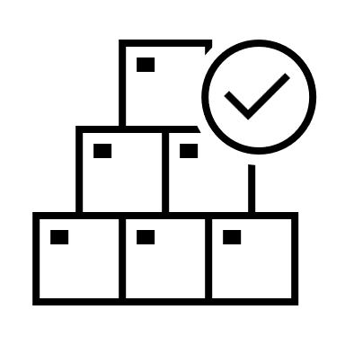Congratulations, you have successfully created a Docker to host a Node application.